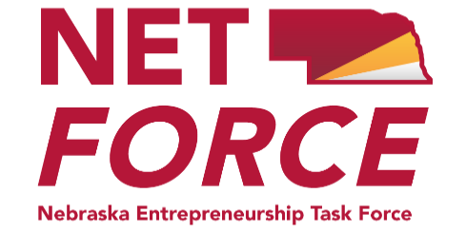

Quarterly Meeting

Friday, February 21st

10:00 a.m. (CST) / Networking at 9:30am

University of Nebraska at Kearney Meeting Hosts:
(Location to be determined)
Kearney, NE

Please RSVP to April Myers, aprilm@nebbiz.org by 5:00 p.m. on Tuesday, February 18, 2020 regarding your attendance and lunch plans.

Submit new agenda items to Marilyn Schlake, NETForce Chair at mschlake1@unl.edu

or April Myers, Secretary at aprilm@nebbiz.org.
Zoom Meeting Connections forthcoming

Tentative Agenda

- Informal Networking/Coffee (9:30 a.m.) – Rolls and Coffee

- Greetings/Introductions/Lunch Details (10:00-10:15)

- New Business
- Discussion future directions for Netforce
- Use of funds or new efforts to promote Entrepreneurship
- Expanding Netforce - Membership Recruitment / Partnerships

4. Old Business
- Review 2019 Entrepreneurship Best Practices Summit
  - Evaluation
  - Open discussion – New format to address Western Nebraska
  - Potential Keynote speakers
- Rebranding of NETForce and Eship Summit - Logos
- Entrepreneurship Course – Re-accreditation update – Linda Hartman

5. Begin NET-Force Partner Updates – 3 minute short sharing of key activities (complete information cards)

6. Lunch, Networking and Presentations (Noon-1:00)

7. Continue NET-Force Partner Updates – 3 minute short sharing presentations of key activities, resources available and future events information.

8. Adjourn (2:30)

Reminders/Requests
- Bring copies of any brochures, event flyers, educational/economic development resources you wish to share with the group (20-25 copies)
- Email a copy of the Summary to April Myers, aprilm@nebbiz.org.

o Future events will be shared via the Nebraska Entrepreneurship Education website, Twitter and Facebook. Be sure to include dates, times, and brief descriptions of local, regional and state- wide events.

